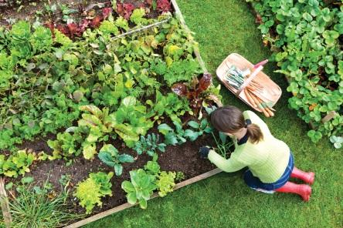
HILLVIEW BAPTIST CHURCH
COMMUNITY GARDEN

2024 Gardener’s Application
Please submit this form ASAP in one of the following ways:
- In person to the church office during open hours (9-Noon, Tues through Fri)
- Via the mail slot just right of the main doors at 253 Woodvale Road West
- By email to HillviewBaptistGarden@gmail.com

NAME:

ADDRESS:

PHONE: EMAIL:
PLOT SIZE REQUESTED:
- ☐2’ x 8’
- ☐4’ x 8’

Usage Agreement
- I understand that neither the Hillview Baptist Church, its affiliates or representatives are responsible for my actions and will not be held liable for any damage, loss or claim that occurs in connection with the use of the garden by me or my guests.
- I have read the included guidelines and am in agreement with all of the expectations for my participation in the community garden. I am aware that failure to meet these expectations may result in my termination as a plot holder of the garden.
- I have read and understand all the HBC Community Garden Bylaws and Terms of Reference.
- A deposit of $20 cash per plot is required for each Plot holder to reserve a plot for a season. This deposit will be returned at the end of the growing season if the plot has been maintained as outlined in the agreement and is left clean at the end of the season.

Typing your name will constitute a signature

SIGNATURE DATE
* Personal information collected will only be used to contact gardeners with information and updates pertaining to the community garden and related events

HILLVIEW BAPTIST CHURCH (HBC) COMMUNITY GARDEN MISSION:
God has blessed us with a wonderful space in the middle of the Hillview neighbourhood. In order to extend His love and to bless those around us, we undertake to:
- Foster a community of knowledge in the area of gardening and food production.

- Provide a friendly space where fellowship and interconnectedness can happen within the Hillview neighbourhood – where people can meet, greet, share knowledge, produce, and comradery.

- Promote intergenerational and intercultural interactions.

- Create a place of beauty for others to enjoy.

GENERAL GUIDELINES FOR PARTICIPATION
- All participants are expected to respect the plots of other gardeners and to look out for the well-being of the garden as a whole. Each plot holder is responsible for the activities of all children, pets, or guests in their company while on-site.

- Plot Holders recognize that this garden is in a public location and as such is subject to vandalism and theft. All participants will assist in promoting the security of the site. Any plot holder found misusing or stealing garden assets will be asked to give up their plot.

- The garden does not run itself, and as such all gardeners are expected to participate in all activities for the common good, including spring garden preparation, fall clean-up, and area maintenance throughout the growing season.

- All plot holders and guests participate in the garden entirely at their own risk.
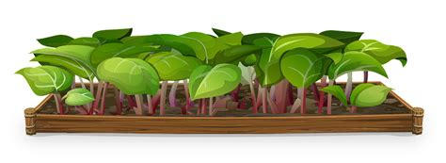

PLOT SELECTION AND USE
- Plots will be assigned at the discretion of the HBC garden coordinator.

- Plot holders will be responsible for the development of their own garden plot and are encouraged to assist other gardeners.

- Abandonment or serious neglect of a plot will result in that plot being un-assigned from the plot holder responsible for its maintenance, and it may be re-assigned to another plot holder as deemed appropriate by the HBC garden coordinator.

- Plot Holders in good standing may have the option of retaining the same plot year-to-year.

PLANTING, MAINTENANCE & HARVESTING
- Planting begins May 1 (weather permitting). A plot that is not fully planted and weed-free by June 1 may be re-assigned.

- Plot Holders are responsible for supplying their own seeds and tools and for planting their own plot.

- The following are not permitted to be planted in the garden: invasive species, plants with an invasive root system (ex. horseradish, rhubarb), marijuana, or any illegal plant.

- Perennials must be removed at the end of the season.

- Unless otherwise permitted by the garden coordinator, use of pesticides is restricted to organic varieties, like neem oil, pyrethrin and insecticidal soap

- Plots must be kept tidy and weed-free. If temporarily unable to care for your plot for any reason, it is the plot holder’s responsibility to ask other gardeners to assist with watering/weeding. If a plot holder must abandon their plot for any reason, the plot holder shall advise the HBC garden coordinator at the earliest possible date..

- Harvest is to be completed by October 12st with garden plots left clear of all tools, plant material, and debris. All individually owned stakes, cages, etc. for personal plots must be taken home by the plot holder until the next growing season.

- Watering barrels will be available on site.
- All waste, compost and other materials should be removed to properly designated spaces.
Hillview Community Garden
Year 2 of Growing in our Community
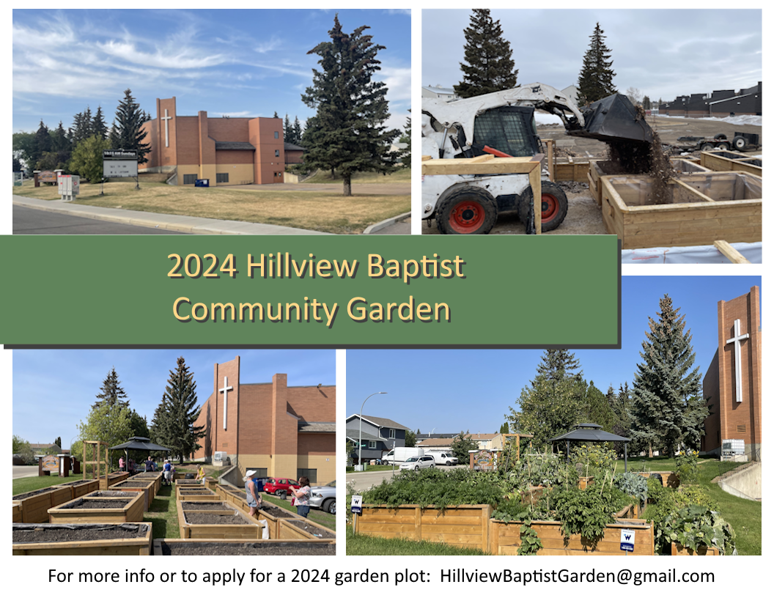

Do you love gardening? Would you like to participate in making the Hillview neighbourhood a more beautiful and vibrant place?
Apply today to use one of our 20 garden boxes for the season!
HILLVIEW BAPTIST CHURCH
253 WOODVALE ROAD WEST

SEEDS IN THE GROUND MAY 2024

2024 GARDEN APPLICATION FORMS CAN BE FOUND AT:
www.HillviewChurch.ca/garden

FOR MORE INFORMATION, PLEASE CONTACT:
HillviewBaptistGarden@gmail.com

